AD LIFECYCLE ARTIFACT | External Design Document – V4.0  High Level Design
Application: OMS | Project Name: Market Knowledge
Author: Raghu K | Project Code:
The External Design represents the high level functional specifications for your application based upon the approved business requirements.
2.01 - OVERVIEW 2
2.02 - REQUIREMENTS TRACEABILITY MATRIX (Business Requirements to External) 3
2.04 – EXTERNAL DESIGN. 4
Conceptual approach 4
Process Flow 4
Process Details 4
2.05 - DESIGN ASSUMPTIONS 7
2.07 - DESIGN RISKS 8
2.13 - TEST CASES 8
2.14 - ERROR HANDLING 9
2.16 – EXTERNAL DESIGN SIGNOFF 10
2.17 - APPENDIXES 11

2.01 - OVERVIEW

This document covers the design of the CRUD (Create, Read, Update and Delete) Atomic services covering all database interactions of the List Of Parts (LOP) database. Each one of these atomic services serves as a layer of abstraction over the LOP.

This makes the database interactions for LOP flexible and not limited to use by just OMS but possibly other MK applications.

2.02 - REQUIREMENTS TRACEABILITY MATRIX (Business Requirements to External)
This provides a cross-reference between the external design’s functional changes and the specific requirements referenced in the Business Requirements Documentation. Each functional change should be listed on a separate line in the table.

Req. # | Business Requirement | E.D. # | External Design Functional Change

2.04 – EXTERNAL DESIGN.

Architecture Overview

The context for the CRUD services is established in the architecture overview shown below:

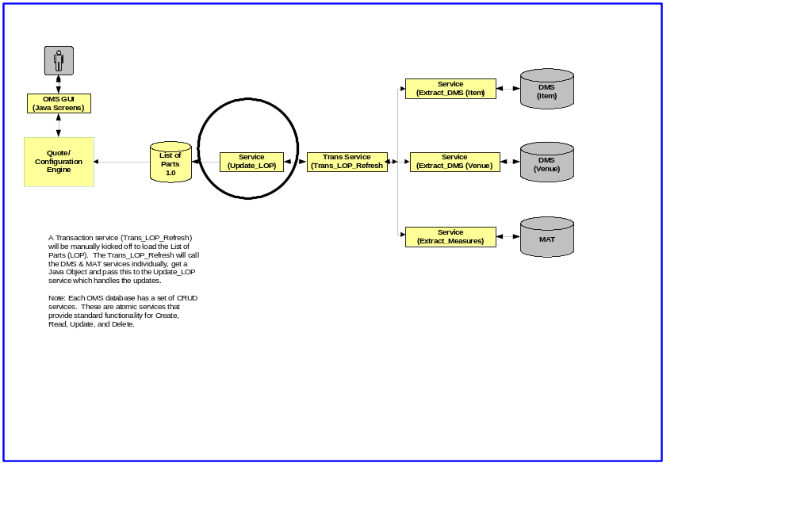

The transactional service (Trans_LOP_Refresh) calls the atomic service (Update_LOP) in order to interact with the LOP database and update data in certain tables in the LOP.

Process Flow:
1 | New Item information is available to OMS from DMS (Item) | The transactional service (Extract_DMS_Item) will pull the data from the DMS (Item) repository. It is yet to be decided if the Extract_DMS_Item will be invoked as a “pull” or a “push”.
2 | The new Item information is prepared to be created/updated into the LOP database | The control is passed to the transaction service (Trans_LOP_Refresh).
3 | The database operation (Insert/Update) on LOP is completed. | Trans_LOP_Refresh invokes the LOP_CRUD_Service to perform the database operation.

The scope of the CRUD service on LOP is to handle the create, read, update and delete operations for the following elements:

- Product/Item Category elements
- Venue Group elements
- Measures
- Client/Customer information.

Detailed Specifications:

- Product/Item Category elements:

The Trans_LOP_Refresh service calls the LOP_CRUD_Service to create/update Product/Item category elements in the LOP.

For Iteration 2, the goal is to do a complete reload of the LOP tables. This means that every time the service is invoked, the data from the LOP is erased and re-inserted. For Iteration 3, we need to have the service do an intelligent insert to handle both creates and updates to the LOP.

The following tables and columns are impacted during a create “Item Category” objec!:
TABLE | COLUMN | REMARKS
HIERARCHY | HIERARCHY_ID | Sequence-generated ID
HIERARCHY | HIERARCHY_NAME
HIERARCHY | NUMERIC_KEY | The KEY/ID from DMS (Item) for the Item hierarchy
HIERARCHY | HIERARCHY_TYPE_ID | FK relationship with HIERARCHY_TYPE. Helps to know if it is an Item Hierarchy or a Venue Hierarchy
HIERARCHY | EFF_DATE
HIERARCHY | EXP_DATE

- Venue Group elements:

The Trans_LOP_Refresh service calls the LOP_CRUD_Service to create/update Venue Group elements in the LOP.

For Iteration 2, the goal is to do a complete reload of the LOP tables. This means that every time the service is invoked, the data from the LOP is erased and re-inserted. For Iteration 3, we need to have the service do an intelligent insert to handle both creates and updates to the LOP.

The following tables and columns are impacted during a create “Venue Group” objec!:
TABLE | COLUMN | REMARKS
HIERARCHY | HIERARCHY_ID | Sequence-generated ID
HIERARCHY | HIERARCHY_NAME
HIERARCHY | NUMERIC_KEY | The KEY/ID from DMS (Venue Group) for the Venue Group
HIERARCHY | HIERARCHY_TYPE_ID | FK relationship with HIERARCHY_TYPE. Helps to know if it is an Item Hierarchy or a Venue Hierarchy

- Measures:

The Trans_LOP_Refresh service calls the LOP_CRUD_Service to create/update Measure elements in the LOP.

For Iteration 2, the goal is to do a complete reload of the LOP tables. This means that every time the service is invoked, the data from the LOP is erased and re-inserted. For Iteration 3, we need to have the service do an intelligent insert to handle both creates and updates to the LOP.

The following tables and columns are impacted during a create “Measure” objec!:

TABLE | COLUMN | REMARKS
MEASURE | MEASURE_ID | Sequence-generated ID
MEASURE | MEASURE_NAME | Measure Name
MEASURE | NUMERIC KEY | The KEY/ID from Measure Authoring Tool (MAT)
MEASURE | EFF_DATE
MEASURE | EXP_DATE

- Client/Customer information:

The Client information is needed by the Trans Delivery service. Please refer to the EDD: “Trans Process Plan ver 1” document – Page 5 for more details. I have reproduced the sequence diagram for a quick reference:

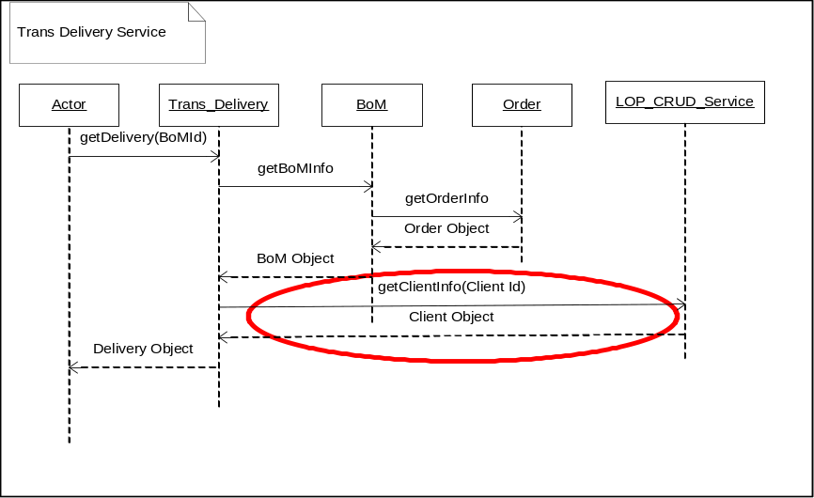

Trans_Delivery calls getClientDataMartInfo on LOP_CRUD_Service passing ClientId. The service returns ClientObject (java). See attached sample:
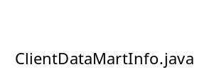

Database Mapping:

The mapping of the Process plan elements to Database fields in CONNECTION table is given below:

connection_type
PPLan XML tag -> database table column

“DATABASE”
<DB_HOST> -> HOST_NAME
<DB_SERVER> -> DATABASE_ID
<DB_PORT> -> PORT_NUMBER
<DB_NAME> -> DB_CONNECT_NAME

<DB_USER> -> CONNECT_USER_ID
<DB_PASSWORD> -> CONNECT_PASSWORD

“AS_MODEL”
<AS_HOST> -> HOST_NAME
<AS_PORT> -> PORT_NUMBER

<AS_USER> -> CONNECT_USER_ID
<AS_PASSWORD -> CONNECT_PASSWORD

CONNECTION_TYPE table will contain the indicator identifying “AS_MODEL” or “DATABASE” so we know what we are looking at and what fields to use.

CLIENT_CONNECTION table will contain the mapping from CLIENT to CONNECTION.

For Iteration 2 I believe a client will have only 2 connections and AS_MODEL and a DATABASE. (This is not enforced by the schema it allow any number). In later iterations the client may have choices as to what AS model and what database to use. Also there may be syndicated connections that are related to more than on client. At this point a new data structure or column would be needed on the order to capture the selected database and as_model from the available for the client.

2.05 - DESIGN ASSUMPTIONS

- HIBERNATE 3.0 will be used to handle/abstract all table-level interactions.
- The scope of this document is limited to creating CRUD services for the following key elements of LOP:
  - Venue Groups
  - Product Categories
  - Measures
  - Clients/Customers
- All inbound and outbound interactions with the LOP will be provisioned through the LOP_CRUD_Service.

2.07 - DESIGN RISKS

1. The CRUD services are currently envisioned as “atomic” services with LOP as the scope of operation. A “transactional” service seems to be the only client for the CRUD service. Hence, in the current context, multiple clients may not use the CRUD services. The benefits of the services created will not be fully realized.

2.13 - TEST CASES

TBD

2.14 - ERROR HANDLING

TBD

2.16 – EXTERNAL DESIGN SIGNOFF
This section should list each functional area and representative that needs to approve the External Design in order for AD to proceed with the ‘Build’ process (internal design, coding, testing). Executive sponsors, project managers, ITO, representatives of affected application and User functional areas, etc. should be included

The functional areas listed below are examples. Add and delete as appropriate.

Signoff - Name | Functional Area | Signoff Date
 | Project Sponsor −
 | Executive Sponsor −
 | Marketing & Consulting Services
 | InfoScan Product Management
 | AD – Order Processing
 | AD − Dictionary
 | AD – Delivery
 | AD – Projections
 | AD − Data loading
 | Commercial Software
 | Database Services − Support Groups
 | Database Services − Operations Control
 | Database Services − Requirements
 | Database Services − Requirements
 | Database Services − Data Input
 | France
 | Italy
 | Germany
 | UK
 | Holland
 | Spain
 | ITO
 | Mosaic InfoForce Partners
 | Project Initiation
 | Project Manager
 | QA
 | R&D
 | RDA
 | Sales Planning & Operations
 | Sampling & Projection

2.17 - APPENDIXES

